Lecture 17

CPSC 131  
11/2/2020

1. Trees
   1. What is a tree?  
      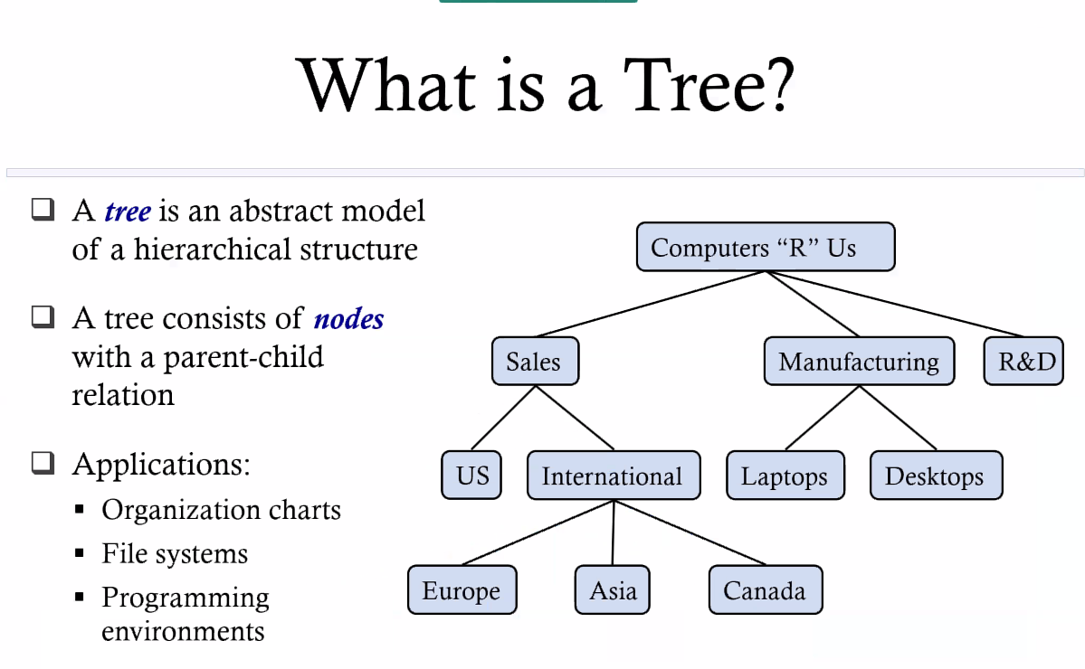
   2. Tree terminology  
      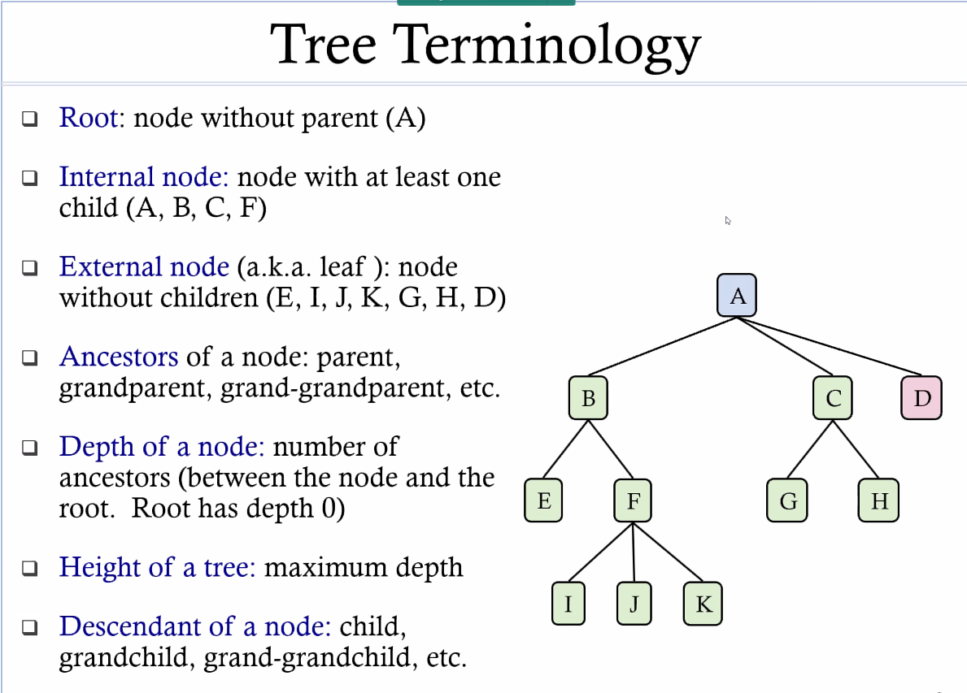
   3. Defining a Node in C++  
      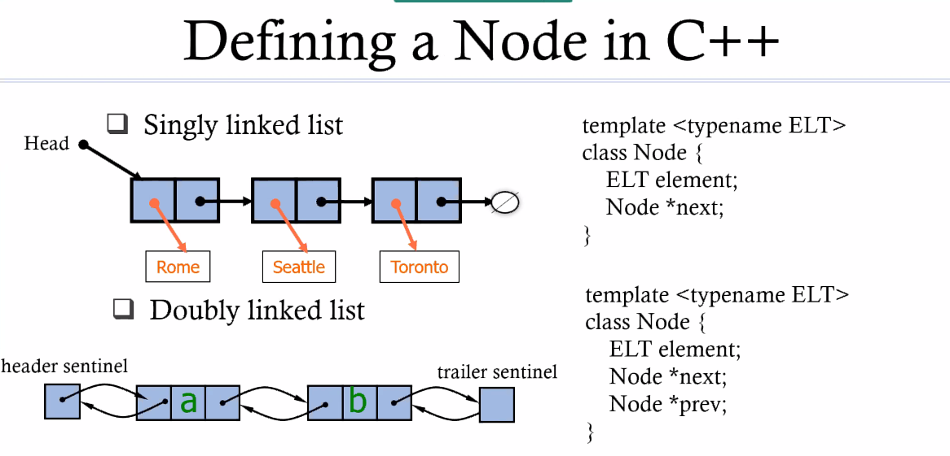
      1. Singly: Let’s start at the beginning and then go all the way down until we reach the end
      2. Tree  
         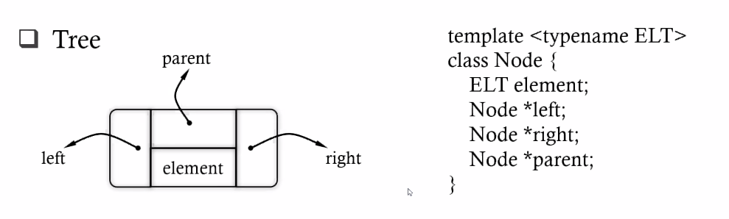
         1. Let’s add a 3rd pointer to the node and we’ll call it parent
   4. Tree traversal  
      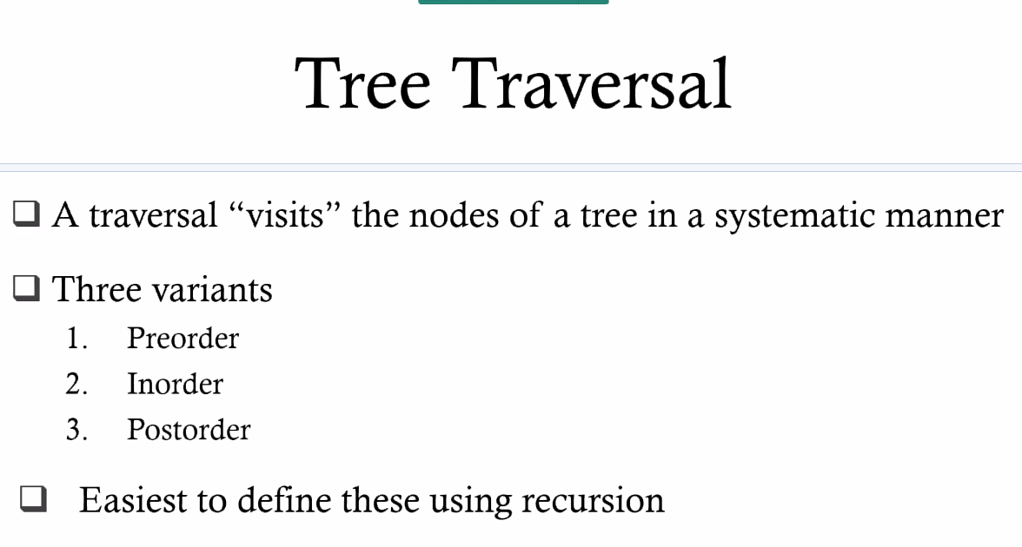
      1. The recursive state: if you’re not at the base case, start with simpler, smaller thing to resolve
   5. Preorder Traversal
      1. 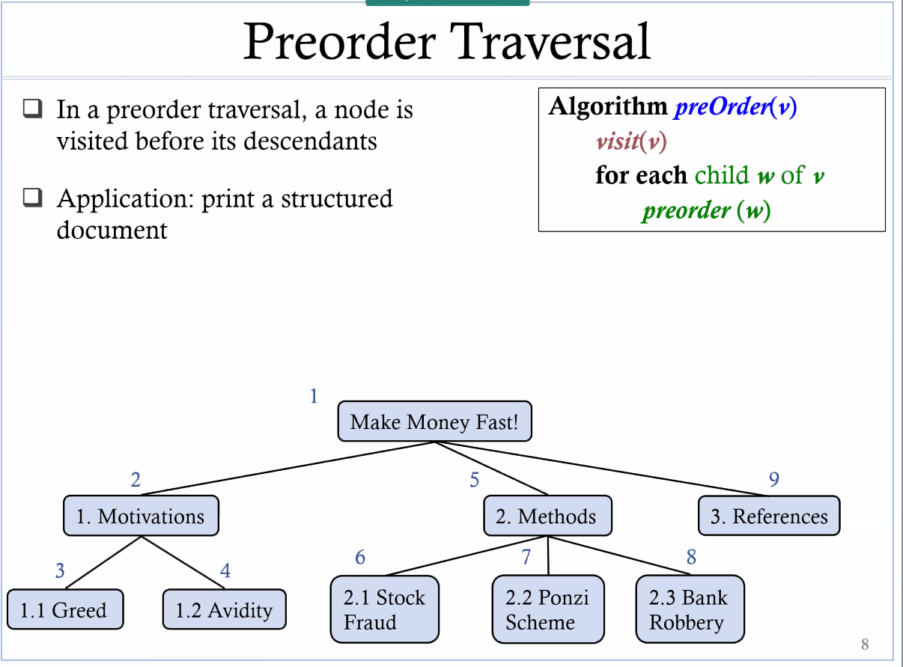
         1. We start at the root and then go top-down
         2. The code  
            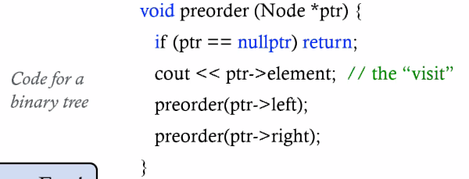
      2. Inorder Traversal
         1. 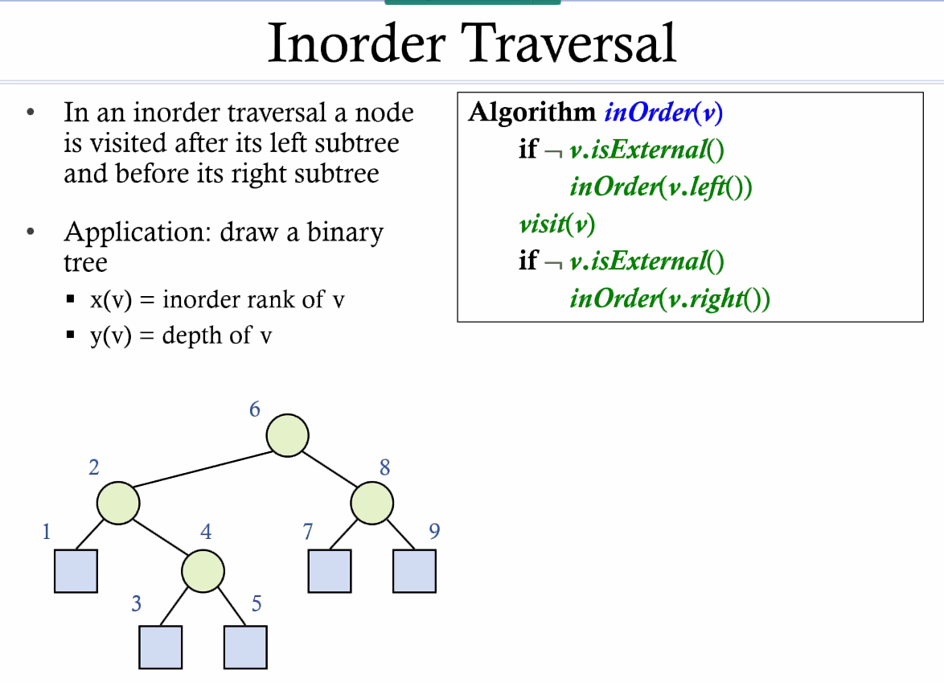
         2. Leaf to parent to root from left to right
         3. Aaaaaaaaaaaaaaaaaaaaaaaaaaaaaaaaaaaaaaaaaaaaaaaaaaaaaaaaaaaaaaaaaaaaaaaaaaaaaaaaaaaaaaaaaahhhhhhhhhhhhhhhhhhhhhhhhhhhhhhhhhhhhhhhhhhhhhhhhhhhhhhhhhhhhhhhhhhhhhhhhhhhhhhhhhhhhh
   6. Print Arithmetic Expressions
      1. 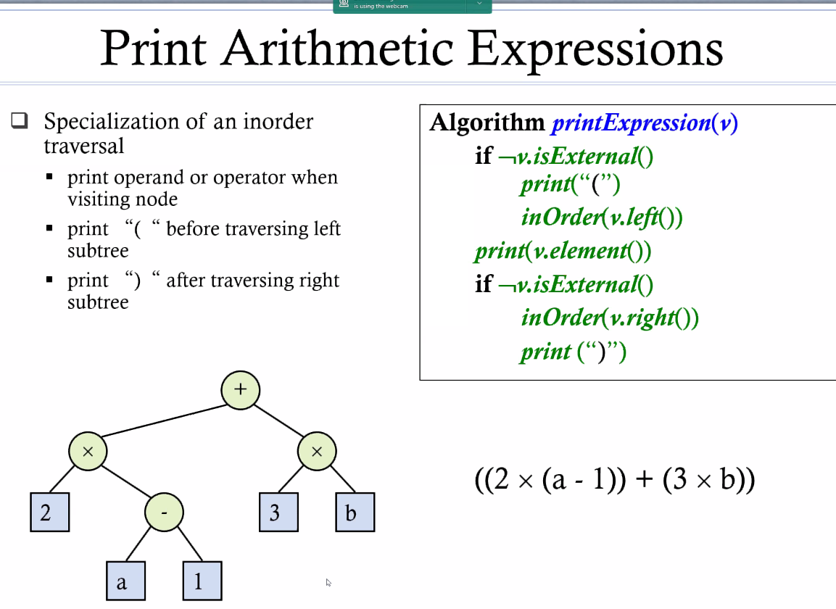
   7. Postorder Traversal
      1. 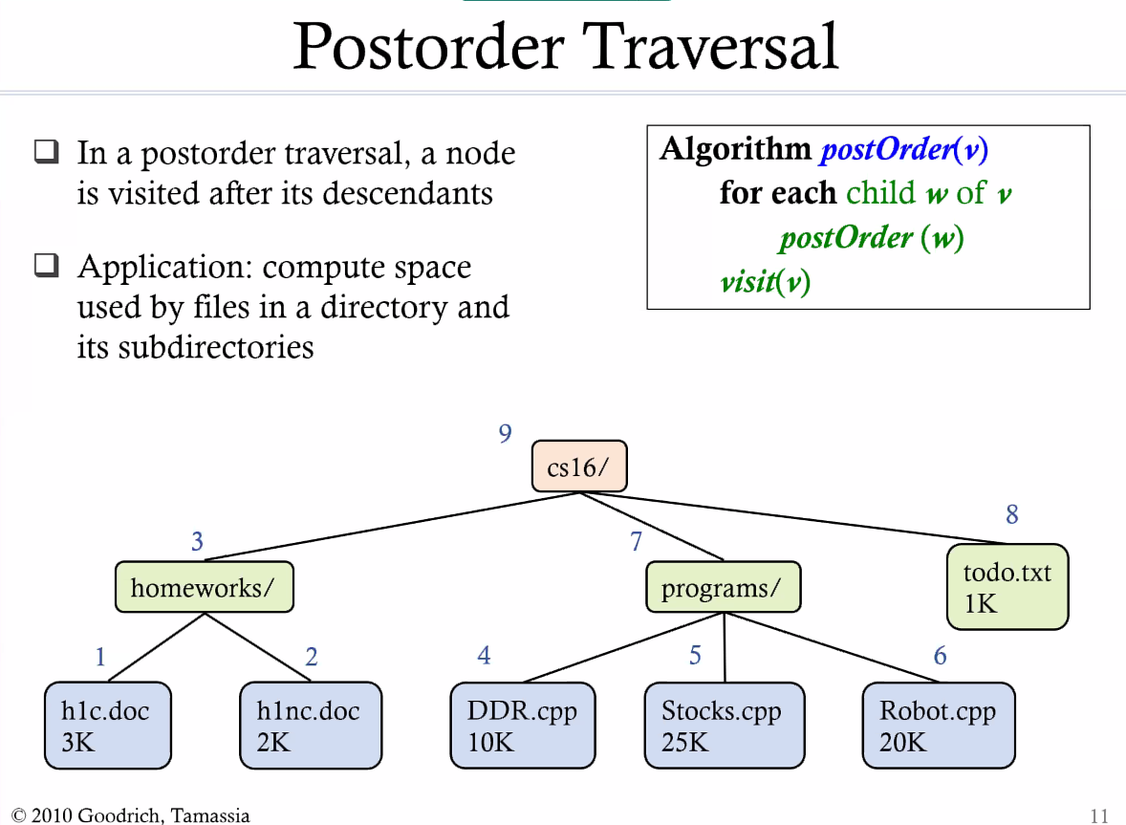
      2. Leaf to parent to root, left to right
      3. Note: the difference between postorder and inorder is that postorder always takes care of leaves first
      4. The root is the absolute last
   8. Euler Tour Traversal Technique  
      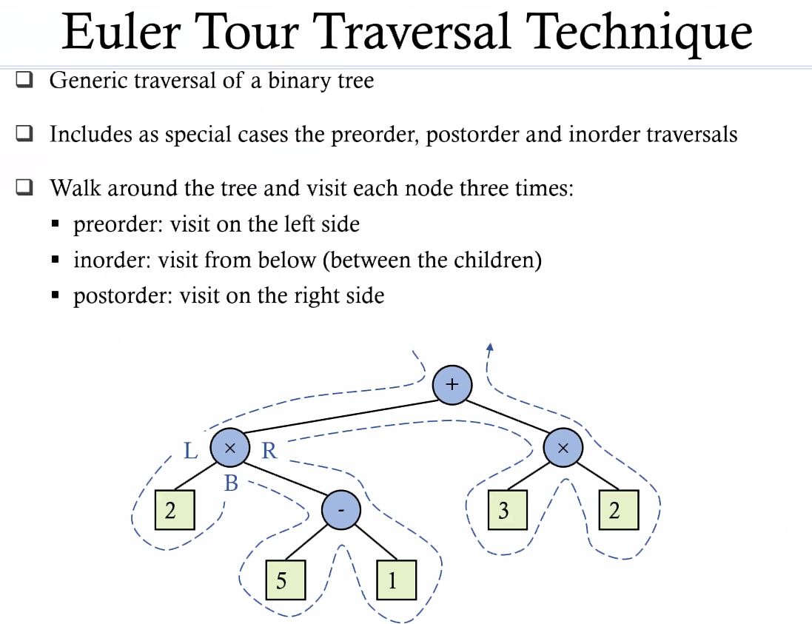  
      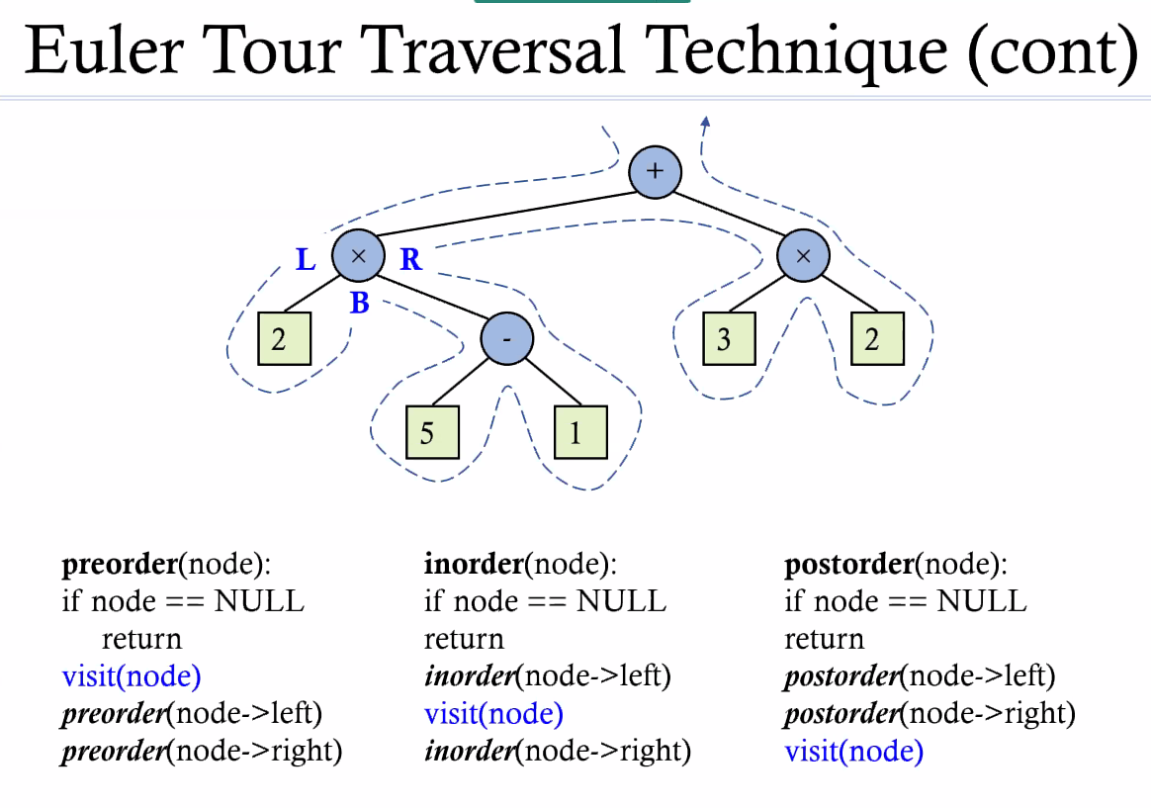
   9. Preorder Traversal  
      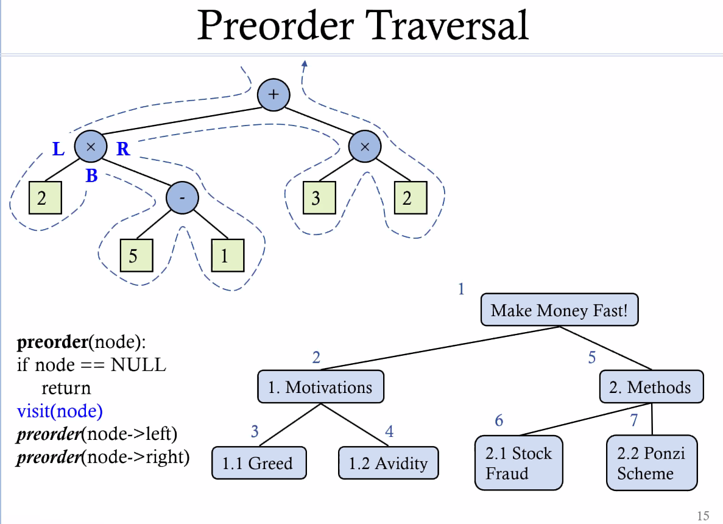
   10. Inorder  
       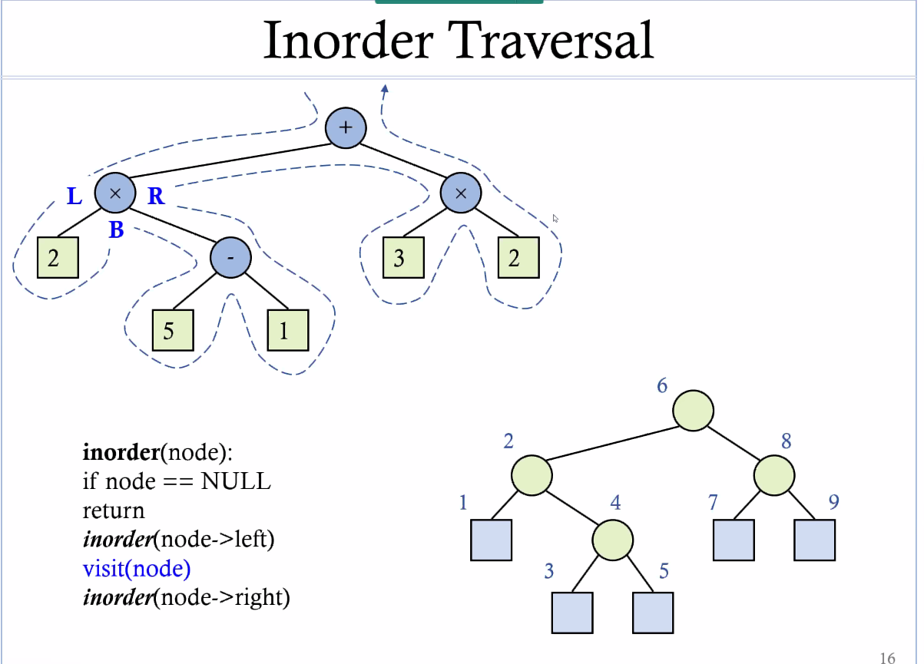
   11. Postorder Traversal  
       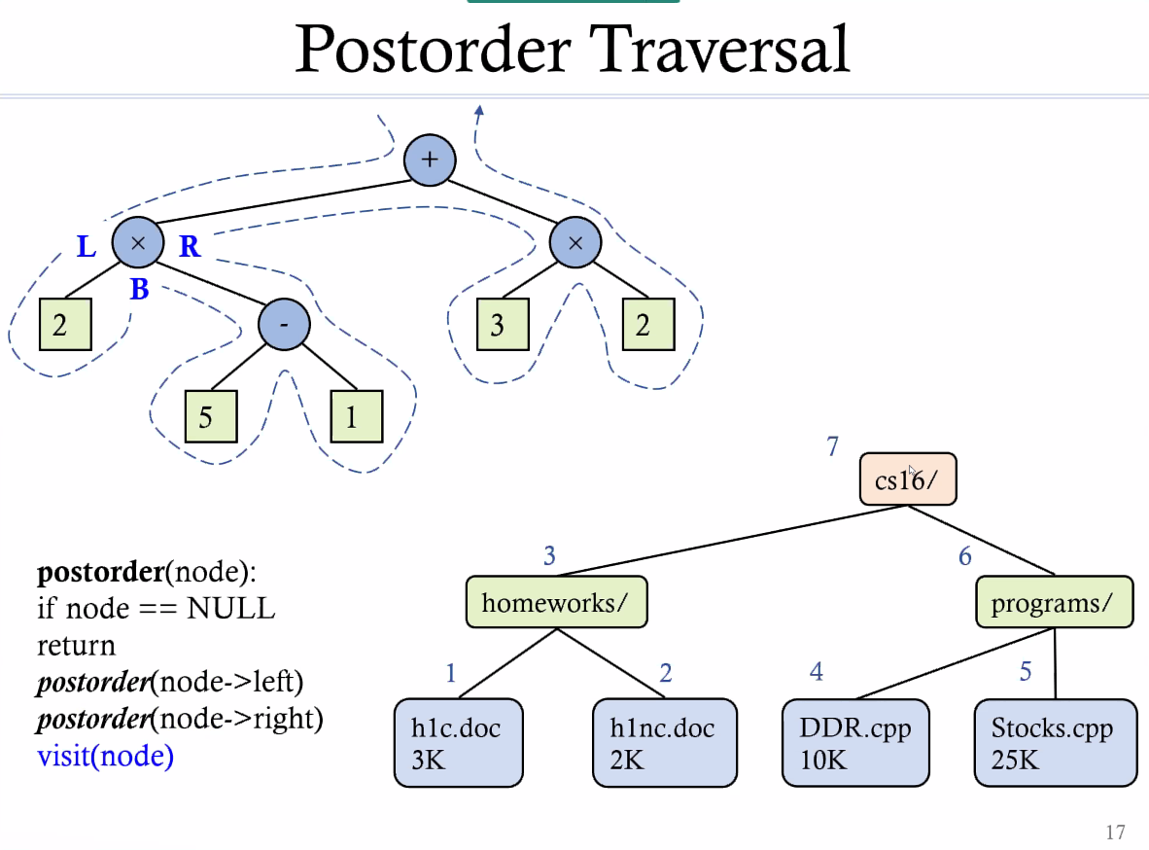
   12. Note: We’re always going to go left then go right
2. Binary Search Trees
   1. Properties of Binary Trees  
      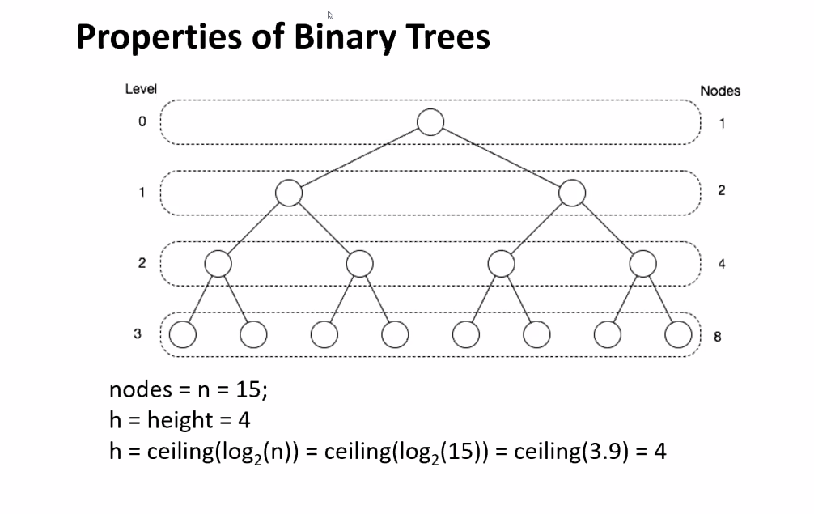
      1. This is a perfect tree
   2. Examples  
      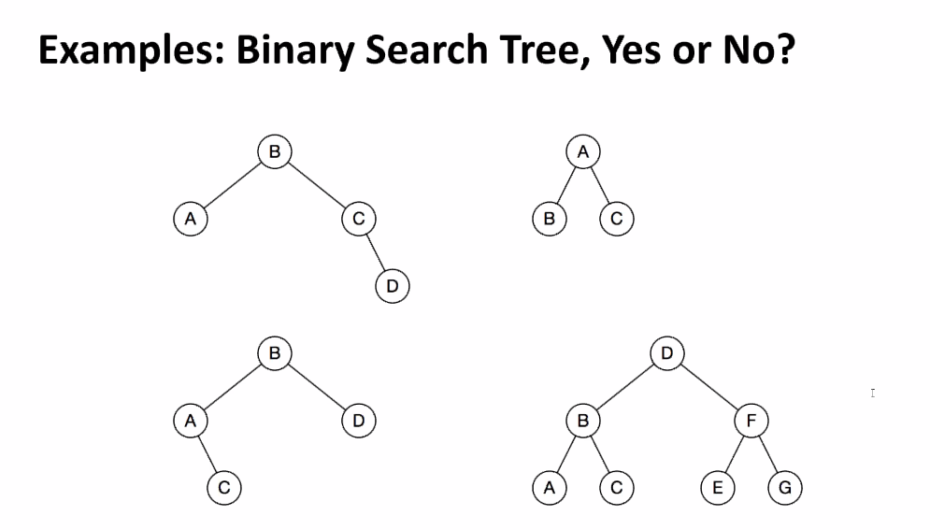



* + 1. Example Search Tree  
       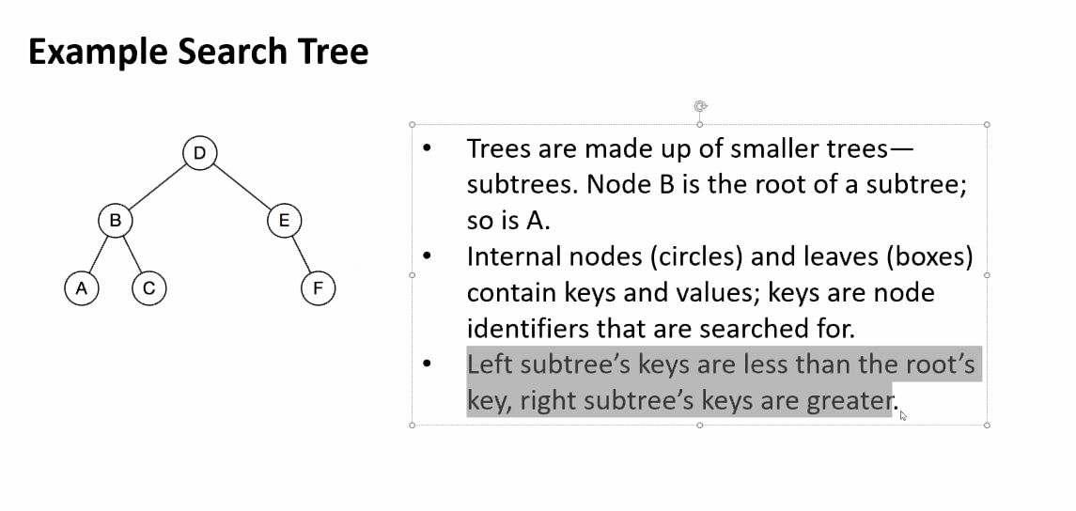

1. C++ Implementation
   1. Insert  
      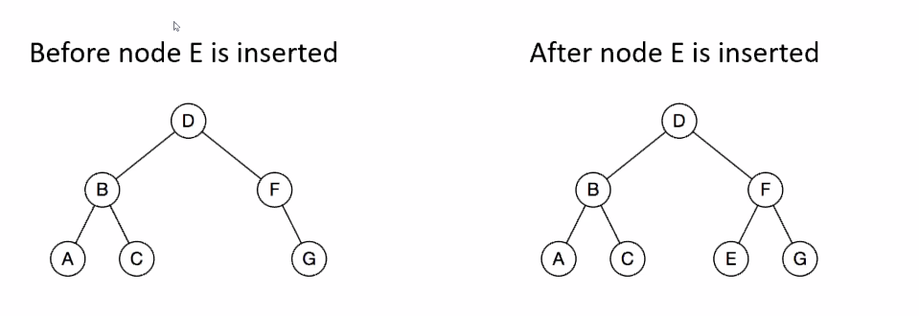
   2. Find  
      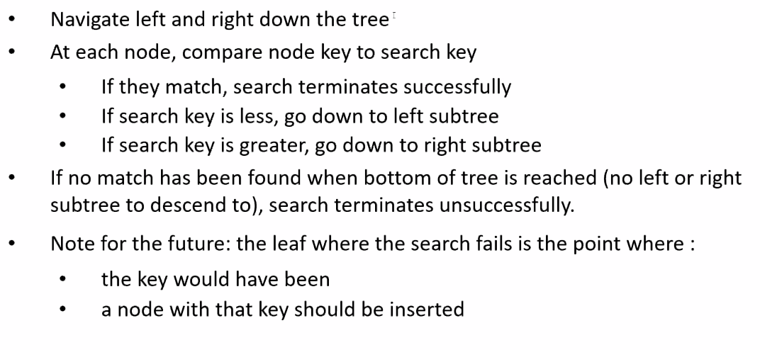
      1. Traversal wise: We don’t need to go through each node. So the first thing we do is compare what we have with what we are looking for
      2. Preorder traversal
2. Binary Search Tree Code
   1. 